Unit Test: Unit 1  
Square Roots and the Pythagorean Theorem

1. Use a diagram to explain why 81 is a perfect square.

2. A number has 11 factors.   
Is the number a perfect square? Explain.

3. Find the length of the indicated side in each triangle.

a)

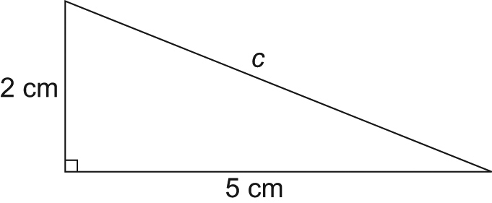

b)

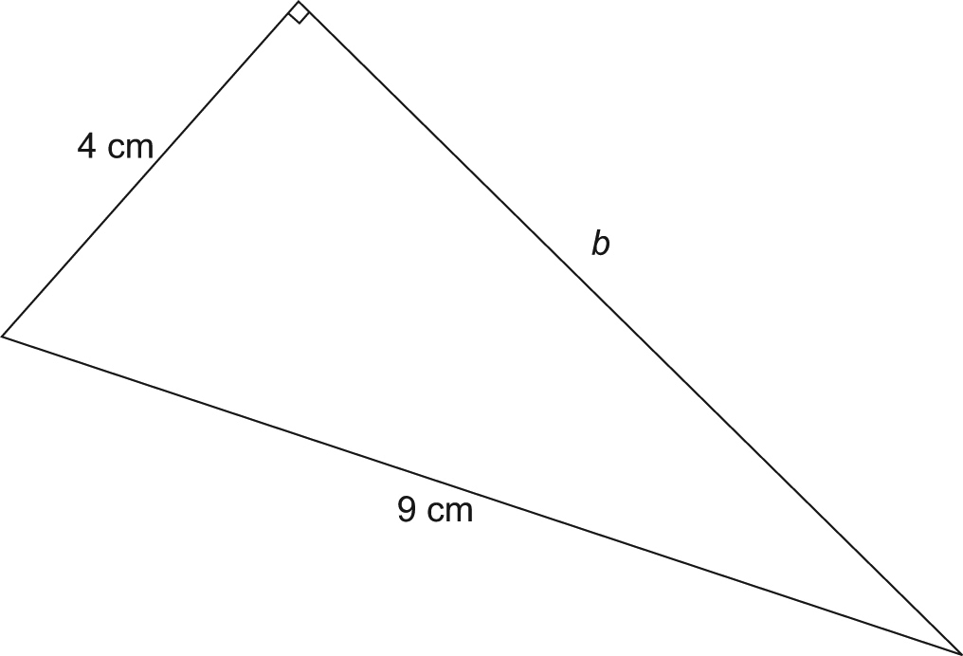

Unit Test continued

4. Find the length of the diagonal, d, in this rectangle.

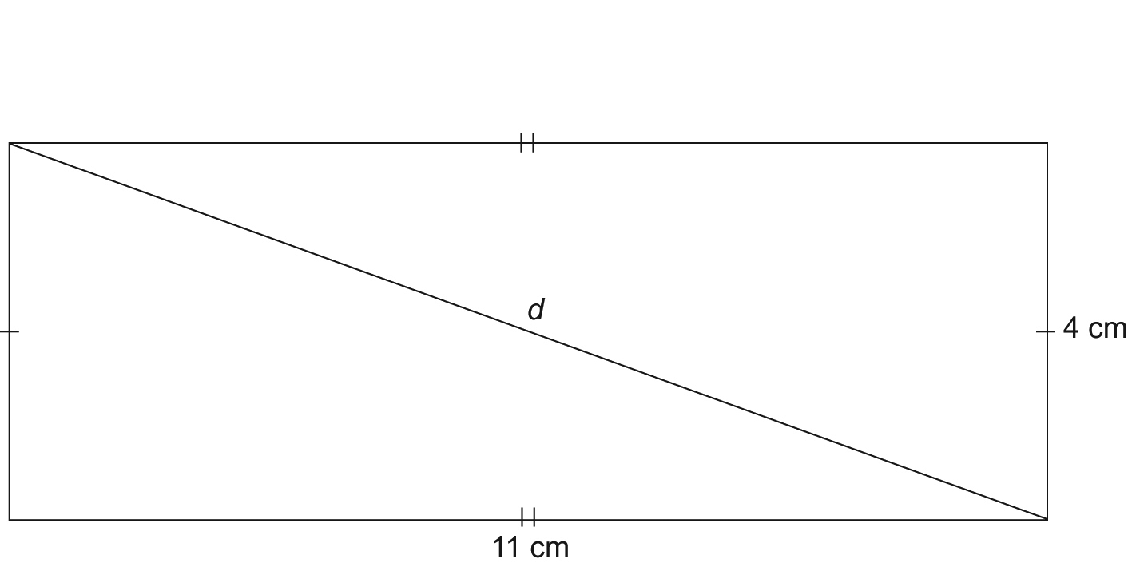

Unit Test continued

5. Simplify.

a) 132 b)  c) 

6. Is each statement true or false? Explain.

a) is between 10 and 11.

b)  ×  = 7

c) 6, 14,  is a Pythagorean triple.

7. Determine whether a triangle with each set of side lengths is a right triangle.   
Justify your answers.

a) 7 cm, 7 cm, and 10 cm

b) 8 cm, 11 cm, and  cm

Unit Test continued

8. A farmer wants to have a water pipe installed from the water source to his farmhouse.   
He has two options.   
He can have the water pipe follow the rural roads. This option costs $30/m.   
He can have the water pipe go directly to the farmhouse, through his field.   
This option costs $45/m.

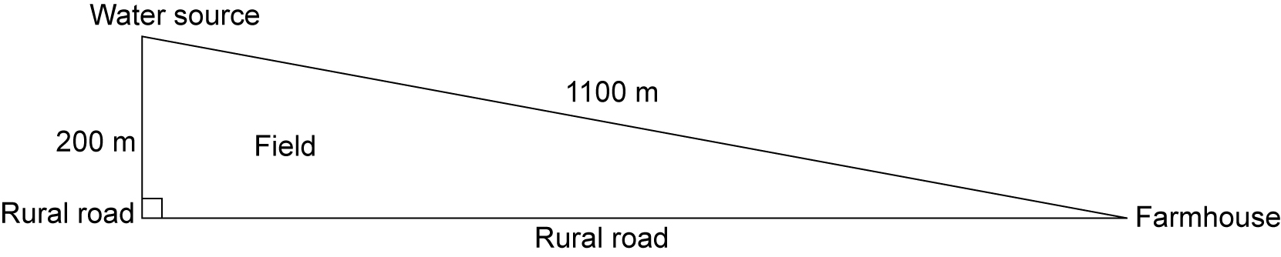

a) What is the cost of running the water pipe directly from the water source to the farmhouse?

b) What is the cost of running the water pipe to the farmhouse along the rural roads?

c) Which is the better option? Explain.