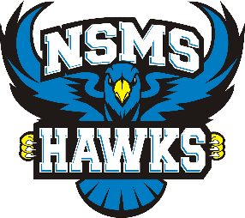
Daily Health Screening

Daily Health Check
Symptoms of illness | Does your child have any of the following symptoms? | CIRCLE ONE
 | Fever | YES | NO
 | Chills | YES | NO
 | Cough or worsening chronic cough | YES | NO
 | Shortness of breath | YES | NO
 | Sore throat | YES | NO
 | Runny nose/Stuff nose | YES | NO
 | Headache | YES | NO
 | Fatigue | YES | NO
 | Diarrhea | YES | NO
 | Loss of appetite | YES | NO
 | Nausea and vomiting | YES | NO
 | Muscle aches | YES | NO
 | Conjunctivitis (pink eye) | YES | NO
 | Dizziness, confusion | YES | NO
 | Abdominal pain | YES | NO
 | Skin rashes or discoloration of fingers and toes | YES | NO
International Travel | Have you or anyone in your household returned from travel outside Canada in the last 14 days? | YES | NO
Confirmed Contact | Are you or is anyone in your household a confirmed contact of a person confirmed to have COVID-19? | YES | NO

If you answered “YES” to any of the questions and the symptoms are not related to a pre-existing condition (e.g. allergies) your child should NOT come to school.
If they are experiencing any symptoms of illness, contact a health-care provider for further assessment. This includes 8-1-1, or a primary care provider like a physician or nurse practitioner.
If you answered “YES” to questions 2 or 3, use the COVID-19 Self-Assessment Tool to determine if you should be tested for COVID-19.

