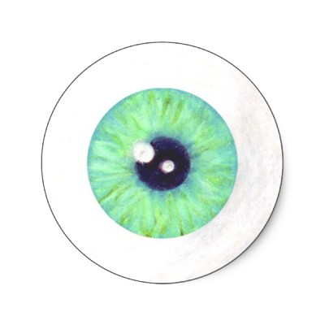
C.S.I Investigator Training:
The Eye and Dissection Skills

Go to the following web site to fill in the blanks below:
http://studyjams.scholastic.com/studyjams/jams/science/human-body/seeing.htm

- The parts of the eye work together to ____________ light and send _______________ about it to our brain.

- Pupils are the ________, __________part of your eye that lets light travel ____________ it. They control the ___________ of light that _____________the eye. In the dark our pupils are ____________and in bright light they _____________.

- The coloured part of the eye is called the ______________. These are usually ________, __________ or ___________.

- _______________ in the iris control the ___________of the pupil.

- We need our eyes, _____________and ________in order to see.

- The light passes through the _____________. The transparent outer layer of the eyeball that covers the iris and pupil.

- The ____________is under the cornea and together they ____________the light rays that pass through them; like a _____________ in a movie theater.

- It projects an _________________image on the retina.

- The __________is the lining at the back of the eyeball. It is _____________ to light. When light hits the retina, it ______________________ of the things you see to the brain through the _____________________.

- The optic nerve is a _____________ of nerves that sends _______________ between the retina and the _____________
My Mark: /7
Click on “Close” and then “Test Yourself”


Go to the following web site: http://www.brainpop.com/
Click “log in” then username: northsaanich password: vikings
Click – Health, Body Systems, Eyes

How is your eye like a film camera?
1. Lens: __________ it ______________ depending on what you are trying to focus just like a cameras ____________.

2. Retina: acts like the ___________ in the camera.

3. When a camera lens focuses an image on film it ends up ____________. When the lens of your eye focuses an image on your retina it also ends up ____________.

Draw it:
Pick an object in the room. In the left square, draw the object the way you see it. In the right square, draw it the way you think it might appear on your retina.
Object | How the object might appear on your retina

Take the Graded Quiz – Record your answers here:
1. _____ 6. _____
My Mark:
/10
2. _____ 7. _____
3. _____ 8. _____
4. _____ 9. _____
5. _____ 10. _____

Close the window and try the virtual eye dissection.

Go to the following website:
http://www.exploratorium.edu/learning_studio/cow_eye/index.html
Click “Watch Online” then click “Watch Step One Video” after each step, click on “Next Video”

Video 1: Why do they do cow eye dissections at the Exploratorium?
__________________________________________________________________________________________________________________

Video 2: How are the muscles in cow eyes and human eyes different? How does this affect the movement of the eyes?
__________________________________________________________________________________________________________________

Video 3: What does the fat around the eye do?
__________________________________________________________________________________________________________________

Video 4: What comes out of the cornea when you make your first incision? What is the purpose of this aspect of the eye?
__________________________________________________________________________________________________________________

Video 5: What is the white part on the side of the eye that you cut in order to cut off the cornea? ___________________

Video 6: What is the iris? What shape is it?
__________________________________________________________________________________________________________________

Video 7: What does the vitreous humor look like, what is it made of, and what does it do?
__________________________________________________________________________________________________________________
Video 8: How is the lens like an onion?
_________________________________________________________

Video 9: What does the lens act like?__________________________

Video 10: What does the retina do?
__________________________________________________________________________________________________________________
Video 11: What is the spot that the retina is attached called?
_________________________________________________________

Video 12: What does your retina become? ____________________

Video 13: How is the back of human eyes different from the back of a cow or cat’s eyes?
__________________________________________________________________________________________________________________

